Director Report 10.20
I reported to you just last month on my summer’s activities so I will try to keep this brief.
Activities
- I have been working on a succession plan—just in case. I have shared it with Jim and it will be on the Governance committee agenda.
- I have been working with the website developer to start posting board materials to a password-protected part of the website so you can always find the documents there.
- Attending NJ Age Friendly conference- 4 mornings on continuing efforts including a good segment on how to evaluate programs
- Attended PEAK Driving Equity
- Attended CNJG Cybersecurity
Coming up:
- Will attend Grantmakers in Aging 2 day conference (zoom)
- On panel for Friends Fiduciary meeting
- Presenting on Housing Options to Concord Quarter
- CNJG annual meeting (virtual) on turning evidence into action Dec 7&8-let me know if you want to attend
Innovation grant reports are attached (single document) Please note the highlighted sentence in Chandler Hall—can FFA help?
Grantee updates
The estimated distribution amount for 2020 is $465,000. $284250 grants made to date. The grant list is attached.
FSA and Kendal have completed the video series: Below is a link to the series on the FSA YouTube channel, thus the FSA logo in the bottom corner; Kendal will be posting them on their channel both their logo as well. At this time, the videos are not available to the public. Preview link: The Quaker Connection Video Series Playlist The official “launch” of the project will be during the week of October 4th, and the videos will become public at that point. Information will going to our collective memberships, as well as to the heads of various Quaker organizations such as Friends Council on Education, FCNL, FGC, etc. Check their website for these and other interesting programs: www.fsainfo.org.
FSA also sent the final papers from 3 of their summer interns. Let me know if you want to read these.
Ohio Senior Living I have not received a formal report, but the last communication indicated training and programs that would have been sufficient to use the remaining funds.
Jaisohn has not provided a report nor a request for going forward. Conversations over the past 6 months indicated that they were using existing staff not a new hire, and that little was happening in social services as they were focusing on medical care.
Barclay Friends Raised beds are done. Need residents to move in.
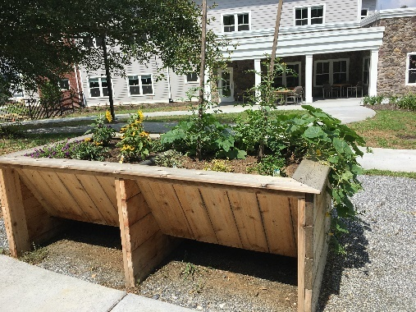
Notes for this meeting:
QVS – Programs are up and running with communal living and virtual placements. Seeking verbal commitment to continue funding in 2021-22.
Trinitas Their proposal from Spring was approved, but funding held as we could not see how they could do Community Health Workers in a pandemic. Lucy and two part-time community health workers have been out in the community for several months, assisting with a range of support (including a virtual support group followed up by food delivery). Visits are welcome as loneliness and isolation are common. They request funding for 2 current CHWs rather than adding more as the Hospital can not cover current salaries and Grotta funding will soon end. Also request an increase to 25 hrs/wk.
Trinitas just sent me a COVID report you might find interesting: treated over 1527 COVID patients, 1250 successfully discharged. All elective surgeries and outpatient services cancelled for 10 weeks, resulting in millions of dollars of lost revenue. The oxygen delivery system froze and required replacement. Peak was mid-April with 195 patients being treated by 705 staff members. A team of 20 RNs from Colorado were brought in to assist. On Aug 7 they had 0 Covid patients. 20,000 meals were donated by the community. Over 46,200 N95 masks, 136,250 surgical masks, 93,500 gowns, and 66,290 face shields were used, plus $400,000 of special equipment purchased.
For those who want to learn more about current trends in the field, I attach these links:
- Four Pillars of New Retirement- ASA https://goto.webcasts.com/starthere.jsp?ei=1356624&tp_key=ea84c4eb11, enter your email address used for registration (shoskins@friendsfoundationaging.org). Or just scan through the slides:https://cache.webcasts.com/content/citr003/1356624/content/5df55d80231c046f9b4c9d399f6b1213a8775797/pdf/Four_Pillars_of_the_New_Retirement.pdf Lots of interesting data about today’s retirees.
- https://www.barrfoundation.org/blog/an-enduring-commitment-to-racial-equity A foundation deepens its commitment to racial equity.
- https://generations.asaging.org/fall-2020 Entire issue is on loneliness and isolation.
- https://www.nextavenue.org/how-to-fix-senior-living/ Experts in the field talk about needed changes in housing for the next generation and post-Covid-19. Current models are not sustainable.
I hope we have time to discuss how FFA wants to respond if there is a pandemic surge this winter and we have emergency requests—or want to focus on a special topic.
I would also appreciate discussion on how you feel about having extra meetings (thank you all for the extra time!) and how to fit these critical strategic discussions into our busy 4-meeting schedule. Are there ways to improve the Zoom experience, or to improve communication?

