Barclay Friends
Final Report to the Friends Foundation for the Aging
CNA Training Program - $25,000 Award
February 2024

- What problem were you addressing? What solution did you propose to address it?

Barclay Friends, like many senior living communities, struggled with staff shortages in key positions such as that of Certified Nursing Assistant (CNA), especially after the pandemic. At the same time, we know that certification as a CNA can be the starting point of a career that can be both rewarding and family supporting. Training takes time and money, both of which are barriers to participation. Barclay Friends sought to overcome those barriers by offering free, paid training to people already working here in entry-level positions. This offered a pathway to career opportunity, while also building a pipeline of diverse healthcare workers which can help to put our Quaker values of compassion, dignity and equality into practice here or at other senior living communities.

- What actions did you take? What worked and didn’t work toward your objectives? Please share any unanticipated benefits or barriers encountered.

Our CNA Training program held four cohorts of training sessions with 19 participants in all. All of the students who started the training completed the full program.

Two CNA candidates in the August 2023 cohort who completed their training did not pass their exam on the first effort. We identified a gap in the skills training we provided, which we addressed in the following cohort by adding a more comprehensive skills training component to our curriculum. This was successful, as 100% of our October CNA trainees passed their state exam. We are supporting the two August students to help them pass their exam this winter. When they do, we will have a 100% completion and success rate with this program.

- How did you measure success--both quantitative and qualitative? Please include numbers and demographics of people touched by the work.

In 2023, Barclay Friends held four CNA Training groups with a total of 19 students. Including the first cohort which was held in the fall of 2022, we have now provided CNA training for a total of 24 individuals. The intention of the program was twofold: to provide a career path for current Barclay Friends employees, especially women of color; and to ensure a pipeline of qualified CNAs who can provide the compassionate care that our residents deserve.

The graduates of the program to date have been overwhelmingly women of color. Of the 19 people trained in 2023, two were male and one was transgender (female to male); all of the others were women. Nearly all of the candidates (18 of 19) were Black, and several were immigrants from Africa or the Caribbean. For these employees, free training for a stable and rewarding career path has extraordinary value.

The graduates of our program have all successfully passed the state CNA exam, apart from the two candidates mentioned above. All have accepted positions at Barclay Friends. The two students who still need to pass their exam are currently working as Resident Assistants at Barclay Friends’ Preston Assisted Living Center; the others are all now employed as CNAs.

Four of the program’s past graduates are currently pursuing further education to become either a Registered Nurse (RN) or a Licensed Practical Nurse (LPN). Barclay Friends supports these employees as they pursue career advancement, through tuition reimbursement and flexible schedules that enable them to attend classes as needed. We expect more of our graduates will pursue nursing careers in the years to come.

Our CNA Training program has multiple benefits for the participants, for Barclay Friends as an organization, and for the residents we serve.

- For the participants, accessing free training in their workplace saves them money and travel time to receive this training elsewhere. They also receive training within the setting in which they will work, and their training includes Barclay Friends’ compassionate approach centering Quaker values.
- The participants who graduate have immediate access to better-paying jobs, as well as support as they plan to advance their nursing careers into the future.
- Barclay Friends acquires a pipeline of skilled, compassionate caregivers who will sustain our resident care into the future.
- Our residents gain a cadre of qualified staff to help care for them, and receive a continuum of care as the people who served as CNAs move on to careers in nursing and retain their relationships with residents over time.

- How did partnerships/collaborations enhance or challenge the project?

External partners were not involved in this project, apart from the necessary training materials from TLC.

- Include a budget and actual for the project during the reporting period.

Please see attached budget to actuals for 2023.

- What conversations have you had on how to sustain the project after the grant, and do you have plans to share your results with other organizations?

Barclay Friends plans to continue the CNA Training Program into 2024 and is now training its winter cohort. There is an ongoing need for CNAs at Barclay Friends, especially as past graduates of the program gain additional education and move into more advanced positions. In turn, the graduates will form the future backbone of our staff, providing care, comfort and companionship to the seniors who live here. The success of our CNA Training Program has been shared with other members of the Kendal Corporation’s family of Quaker senior living communities. The support of the Friends Foundation for the Aging has been critical to help us launch this impactful program, and we are most grateful.

- Feedback on your interaction with FFA would be helpful. How have we helped? Made it harder? What else can we do to facilitate your work?

Your support throughout the process has been much appreciated. The application is thorough and helps us articulate the value of this program.

- Additional comments:

We hope you enjoy this photo of our proud graduates this fall. They are excited to be launching the new phase of a career in healthcare for seniors.

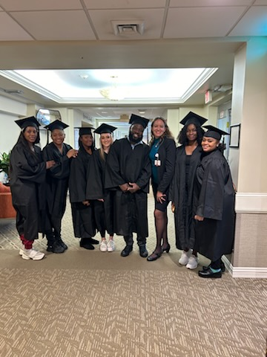

THANK YOU!

